PRESS KIT FOR MEDIA ENQUIRIES

New Religious and Spiritual Movements
Reflexivity, Modernity and Digital Faith
Dr Kion Ahadi · Palgrave Macmillan · Published 22 November 2026 · ISBN 9783032236487
A groundbreaking sociological study arguing that modernity does not erase belief - it reorganises it.
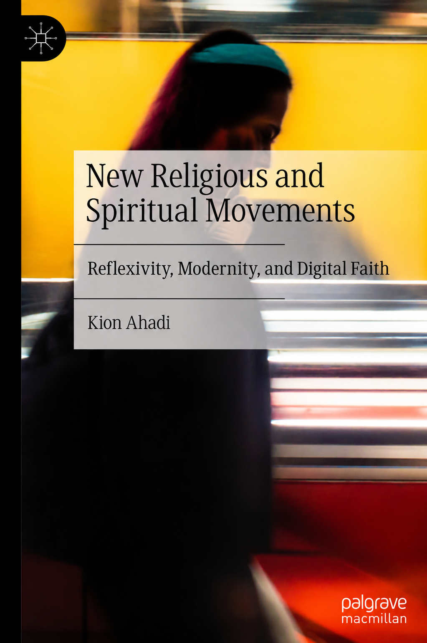
“Modernity does not secularise meaning. It reorganises it.”
AT A GLANCE

Book Facts
TITLE | New Religious and Spiritual Movements: Reflexivity, Modernity and Digital Faith
AUTHOR | Dr Kion Ahadi
PUBLISHER | Palgrave Macmillan
PUBLICATION DATE | 22 November 2026
ISBN | 9783032236487
CATEGORY | Sociology of religion, digital religion, modernity, social theory
PRE-ORDER | Amazon UK, Waterstones, Bookshop.org, Barnes & Noble
FREE READER SAMPLE | 21-page sample available at reflexiverealism.com/free-sample
MEDIA CONTACT | kionahadi@gmail.com
SYNOPSIS

About the Book
For more than a century, classical and mid-twentieth-century sociologists predicted that modernity would erode religion - the secularisation thesis associated with figures such as Max Weber, Bryan Wilson, and (in his earlier work) Peter Berger. Yet belief and spiritual practice persist and proliferate.
From Scientology and Falun Gong to UFO religions, wellness and holistic spirituality, and the digital terrain of WitchTok, Instagram shamans, and AI oracles, contemporary belief systems continue to evolve rather than disappear.
This book challenges classical secularisation theory and argues that modernity does not eliminate meaning - it reorganises it. Drawing on ESRC-funded doctoral research developed over two decades, it combines a longitudinal interview corpus, participant observation, and digital ethnography to present New Religious and Spiritual Movements as powerful indicators of how people construct identity, purpose, community, and transcendence in the modern world.
PRE-ORDER LINKS

Where to Order
- Amazon UK - https://www.amazon.co.uk/dp/3032236487
- Waterstones - https://www.waterstones.com/book/new-religious-and-spiritual-movements/kion-ahadi/9783032236487
- Bookshop.org - https://bookshop.org/p/books/new-religious-and-spiritual-movements-reflexivity-modernity-and-digital-faith-kion-ahadi/5d34640a32eb7f39
- Barnes & Noble - https://www.barnesandnoble.com/w/new-religious-and-spiritual-movements-kion-ahadi/1149660381

KEY CONTRIBUTIONS

What the Book Argues
Reflexive Realism  An original theoretical framework synthesising critical realism (Bhaskar) with Margaret Archer's account of reflexivity. | Origins-Orientations Typology  An original typology for classifying movements by where they come from and how they orient adherents toward the world.
A Wider Diagnosis  Shows how movements illuminate transformations in authority, identity, belief, community, knowledge, technology, and human meaning. | Two Decades of Evidence  A longitudinal interview corpus (2003-2025), participant observation, and digital ethnography of contemporary online spirituality.
SUGGESTED ANGLES FOR MEDIA

Interview Themes
- Why secularisation theory failed to predict the present religious landscape
- Digital faith: WitchTok, Instagram shamans, algorithmic authority and AI oracles
- Wellness culture and holistic spirituality as contemporary meaning-making
- How people build identity, community and transcendence without institutions
- What AI and platform culture mean for the future of belief
TERRAIN COVERED

Movements and Contexts Discussed
Established Movements  Scientology, Falun Gong and other twentieth-century movements read through the origins-orientations typology. | Alternative Cosmologies  UFO religions and esoteric traditions as responses to disenchantment rather than departures from reason.
Wellness and Holistic Spirituality  Therapeutic culture, self-development and embodied practice as sites of contemporary meaning-making. | Digital and Algorithmic Faith  WitchTok, Instagram shamans and AI oracles, and how platforms restructure religious authority.

BIOGRAPHY

About the Author

Dr Kion Ahadi is a sociologist, author, and technology leader whose work spans religion, spirituality, modernity, digital culture, artificial intelligence, and social transformation.
The book grows out of his ESRC-funded doctoral research at Goldsmiths, University of London, where he also taught qualitative and quantitative research methods. It combines a longitudinal interview corpus (2003-2025), participant observation, and digital ethnography with contemporary analysis of digital religion and emerging spiritual life.
Alongside his academic work, he advises organisations on AI, data strategy, governance, and digital transformation, bringing an interdisciplinary perspective to questions of belief, authority, and social change. He is a Fellow of the Royal Society of Arts.

Short bio (50 words)
Dr Kion Ahadi is a sociologist, author and technology leader. His ESRC-funded doctoral research at Goldsmiths, University of London underpins New Religious and Spiritual Movements (Palgrave Macmillan, 22 November 2026). He advises organisations on AI and digital transformation and is a Fellow of the Royal Society of Arts.

Credentials
PhD Sociology (Goldsmiths, University of London) · Author · Speaker · Technology Leader · Fellow of the Royal Society of Arts
PRESS AND PUBLICITY

Media enquiries, interview requests, review copies and event bookings
Email: kionahadi@gmail.com
Website: reflexiverealism.com · Free 21-page reader sample: reflexiverealism.com/free-sample
Endorsements and review quotes are not yet available and will be added once confirmed. Please contact the author directly for the latest publication information.

